# Table of Contents

Table of Contents 1

Visual Studio Code (VS Code) Installation and Navigation Guide 1

Installation of VS Code 1

Steps to Download and Install Visual Studio Code on Windows 11 1

First-time Setup 3

User Interface Overview 3

Main Components of the VS Code User Interface 3

Command Palette 3

Command Palette in VS Code 3

Extensions in VS Code 3

Role of Extensions 3

Finding, Installing, and Managing Extensions 3

Integrated Terminal 3

Opening and Using the Integrated Terminal 3

File and Folder Management 3

Settings and Preferences 3

Debugging in VS Code 3

Key Debugging Features 3

Using Source Control 3

References 3

# Visual Studio Code (VS Code) Installation and Navigation Guide

## Installation of VS Code

### Steps to Download and Install Visual Studio Code on Windows 11

Download VS Code:

Visit the official Visual Studio Code website.

Click on the "Download for Windows" button.

The site will automatically detect your OS and provide the appropriate download link.

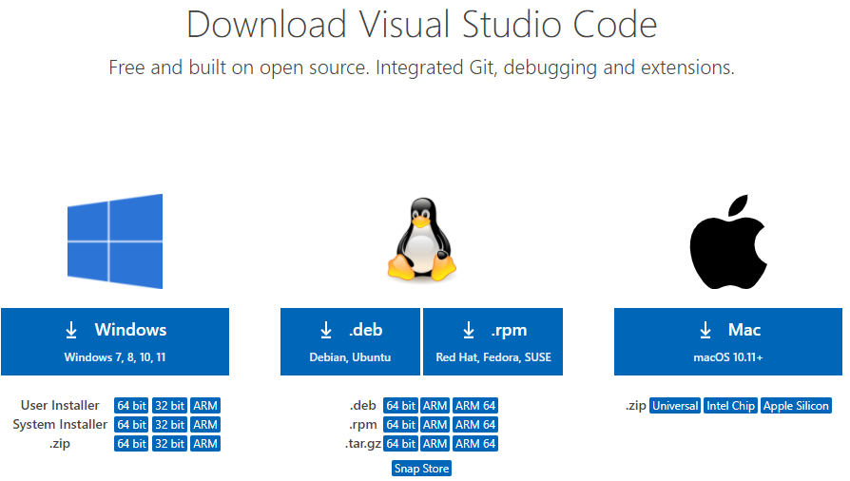2. Install VS Code:

Run the downloaded installer (usually VSCodeUserSetup-x64-<version>.exe).

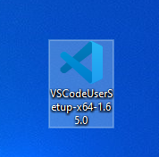

Follow the installation wizard steps:

* Accept the license agreement.
* Choose the installation location.
* Select additional tasks (e.g., create a desktop icon, add to PATH, register code as an editor for supported file types).

Click “Install” and wait for the process to complete.

Once installed, you can choose to launch Visual Studio Code immediately.

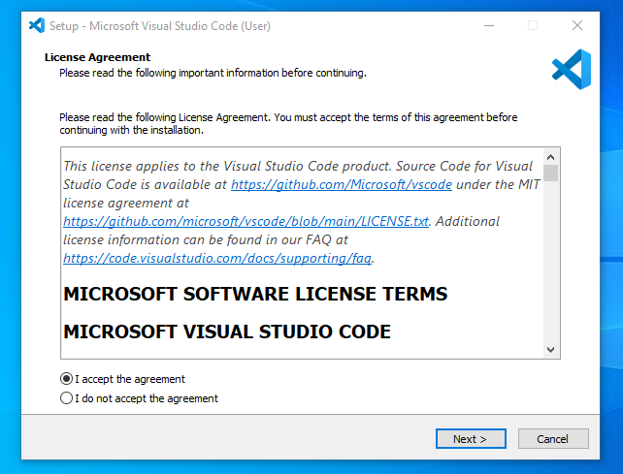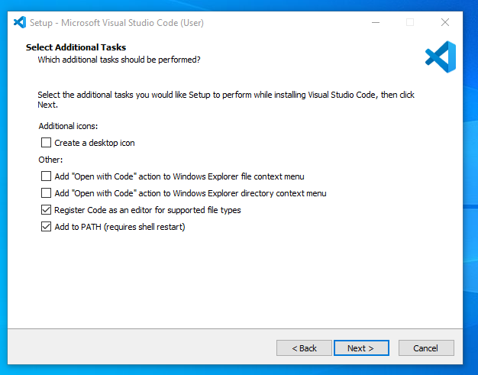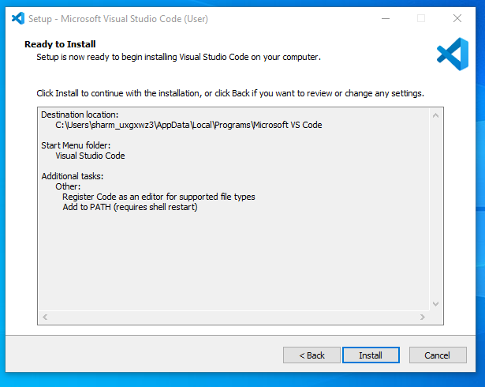

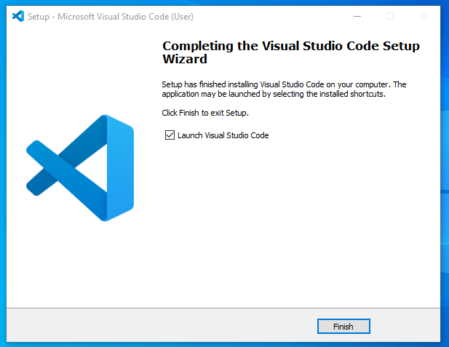

Prerequisites

Windows 11 operating system.

Administrator privileges to install software.

Optionally, a Git client installed if you plan to use source control features.

### First-time Setup

Initial Configurations and Settings

Settings Sync:

Go to File > Preferences > Settings or press Ctrl+,.

Search for "Settings Sync" and sign in with your Microsoft or GitHub account to sync settings across devices.

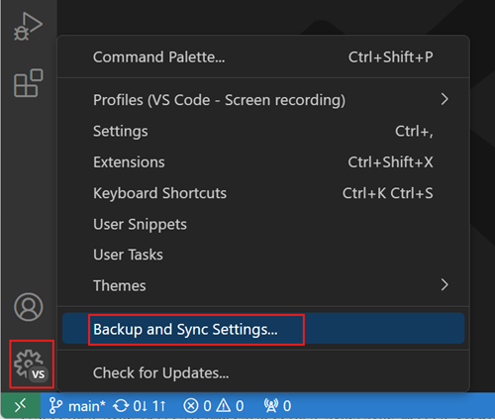

2. theme and Appearance:

* Open the Command Palette (Ctrl+Shift+P) and type Color Theme.
* Choose a preferred theme from the available options.

3. Extensions:

* Install essential extensions:
* Python: For Python development.
* ESLint: For JavaScript linting.
* Prettier - Code Formatter: For code formatting.
* Live Server: To launch a development local server with live reload.
* GitLens: Supercharges the Git capabilities built into Visual Studio Code.



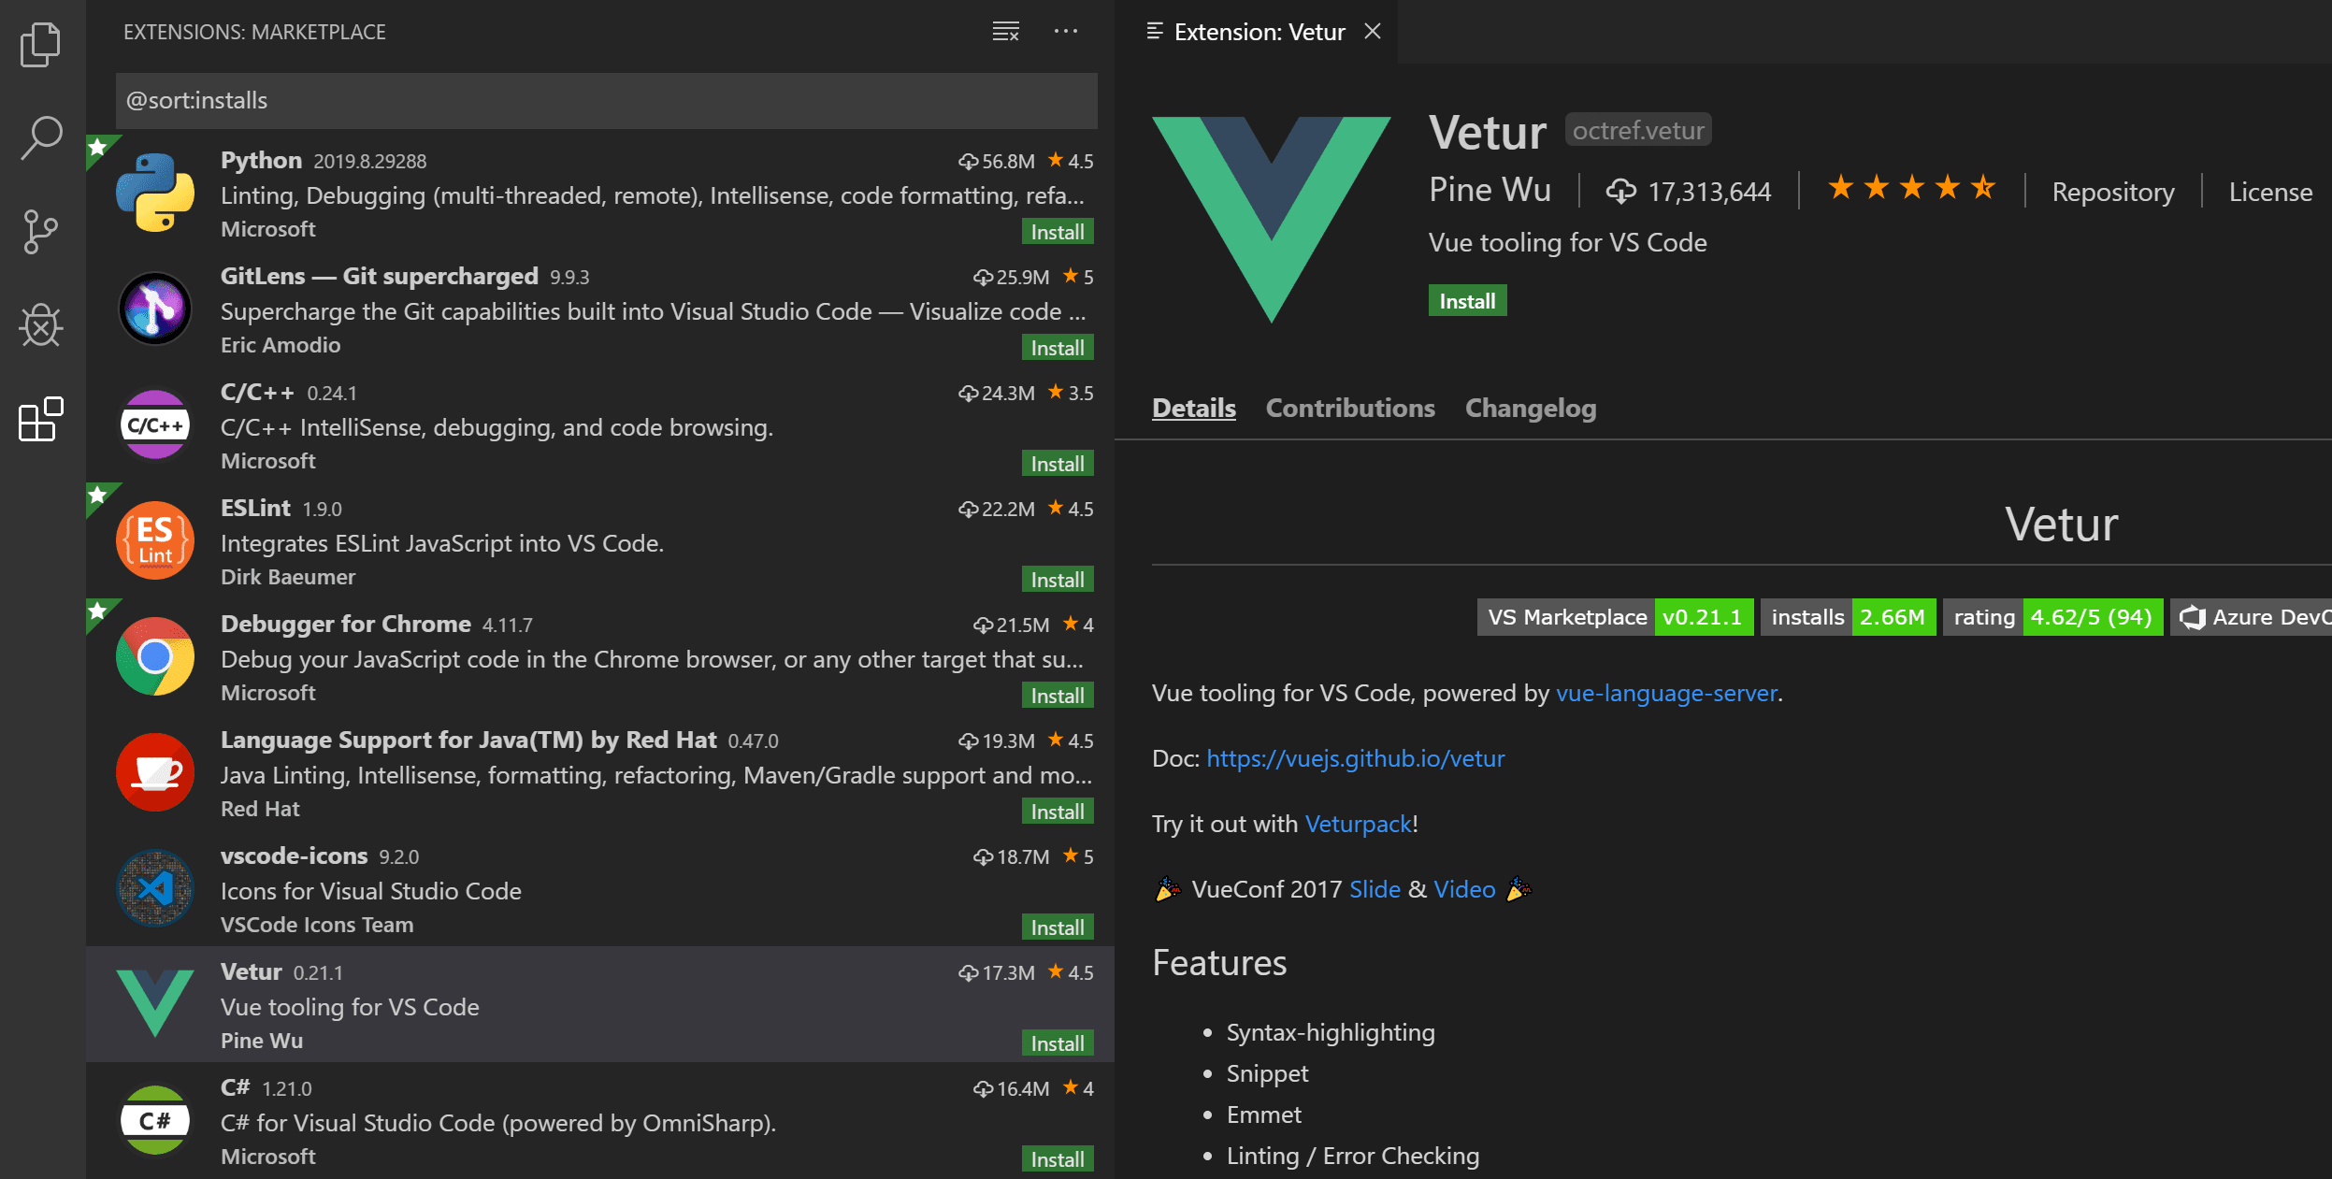4. Editor Settings:

* Configure settings for a better coding experience:
* Auto-save files: File > Auto Save.
* Adjust font size: Ctrl+, then search for "Font Size".
* Enable format on save: Search for "Format On Save" in settings.

## User Interface Overview

### Main Components of the VS Code User Interface

Activity Bar:

Located on the far left.

Provides access to different views such as Explorer, Search, Source Control, Run and Debug, and Extensions.

Side Bar:

Located next to the Activity Bar.

Displays the content of the selected activity, such as a list of files in the Explorer or search results.

Editor Group:

Central area where files are opened and edited.

Supports multiple tabs and split views for side-by-side file editing.

Status Bar:

Located at the bottom of the window.

Displays information about the open file, such as encoding, line ending, language mode, and git branch.

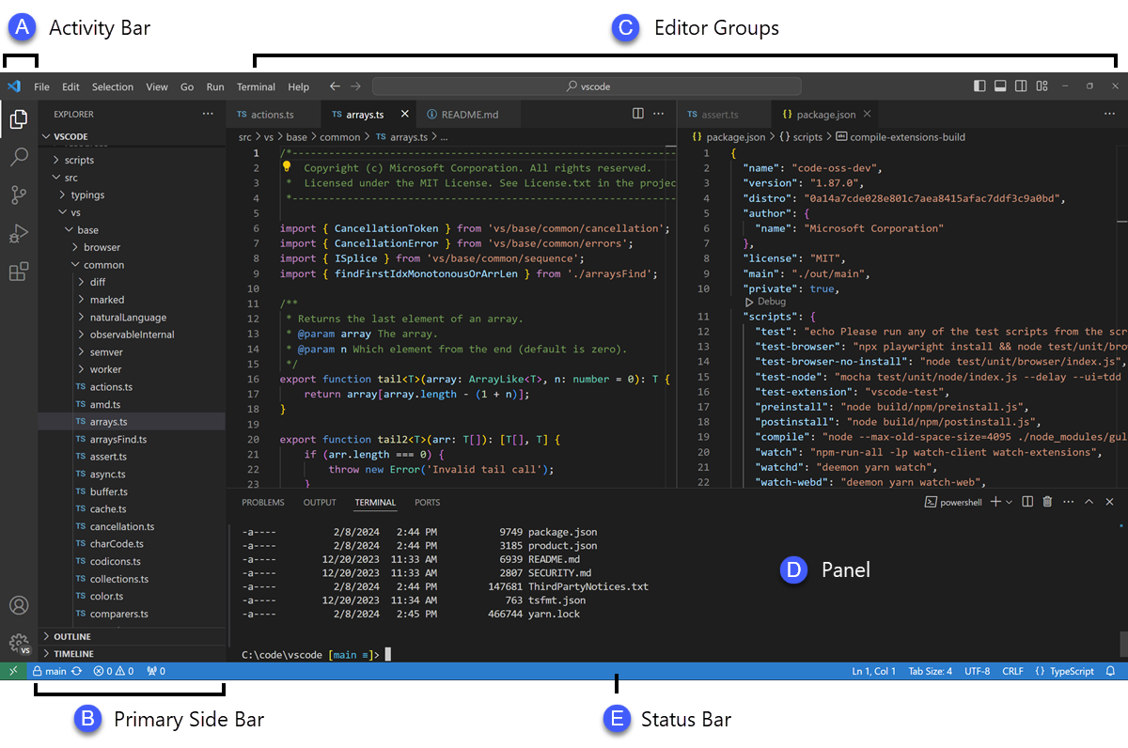

## Command Palette

### Command Palette in VS Code

Accessed by pressing Ctrl+Shift+P or F1.

Provides a quick way to execute commands.

Examples of common tasks:

* Opening Settings: Type Preferences: Open Settings.
* Changing Theme: Type Color Theme and select a theme.
* Running a Build Task: Type Tasks: Run Build Task.

## Extensions in VS Code

### Role of Extensions

* Extend the functionality of VS Code.
* Provide language support, themes, debuggers, and tools.

### Finding, Installing, and Managing Extensions

**Finding and Installing:**

* Go to the Extensions view by clicking the Extensions icon in the Activity Bar or press Ctrl+Shift+X.
* Search for extensions using keywords.
* Click "Install" on the desired extension.

**Managing Extensions:**

* View installed extensions in the Extensions view.
* Disable or uninstall extensions by clicking the gear icon next to the extension.

**Essential Extensions for Web Development**

* HTML CSS Support: Provides CSS class name completion for the HTML class attribute.
* JavaScript (ES6) code snippets: Adds snippets for JavaScript development.
* Path Intellisense: Autocompletes filenames.

## Integrated Terminal

### Opening and Using the Integrated Terminal

1. Open Terminal:

* Use Ctrl+ (backtick) or go to View > Terminal.

2.Using Terminal:

* Supports multiple terminal instances.
* Execute commands directly within the editor.

Advantages

* No need to switch between editor and terminal.
* Directly navigate and operate within the project directory.

### File and Folder Management

**Creating, Opening, and Managing Files and Folders**

1.Creating Files/Folders:

* Right-click in the Explorer view and select "New File" or "New Folder".
* Use the Ctrl+N shortcut to create a new file.

2.Opening Files/Folders:

* Drag and drop files/folders into the editor.
* Use File > Open File or File > Open Folder.

3.Managing Files/Folders:

* Use the Explorer to move, rename, and delete files/folders.
* Use the breadcrumbs navigation at the top of the editor for easy navigation.

### Settings and Preferences

**Customizing Settings in VS Code**

1.Accessing Settings:

* Go to File > Preferences > Settings or press Ctrl+,.

2.Changing Theme:

* Search for Color Theme in settings and select a theme.

3.Adjusting Font Size:

* Search for Font Size and set the desired size.

4.Customizing Keybindings:

* Go to File > Preferences > Keyboard Shortcuts or press Ctrl+K Ctrl+S.
* Modify existing shortcuts or add new ones.

### Debugging in VS Code

**Setting Up and Starting Debugging**

1.Open Debug View:

* Click on the Debug icon in the Activity Bar or press Ctrl+Shift+D.

2.Configure Debugger:

* Create a launch configuration by clicking on the gear icon and selecting the appropriate environment.

3.Set Breakpoints:

* Click in the gutter next to the line numbers in the editor.

4.Start Debugging:

* Press F5 to start debugging.

### Key Debugging Features

Breakpoints, step through code, watch variables, and view call stack.

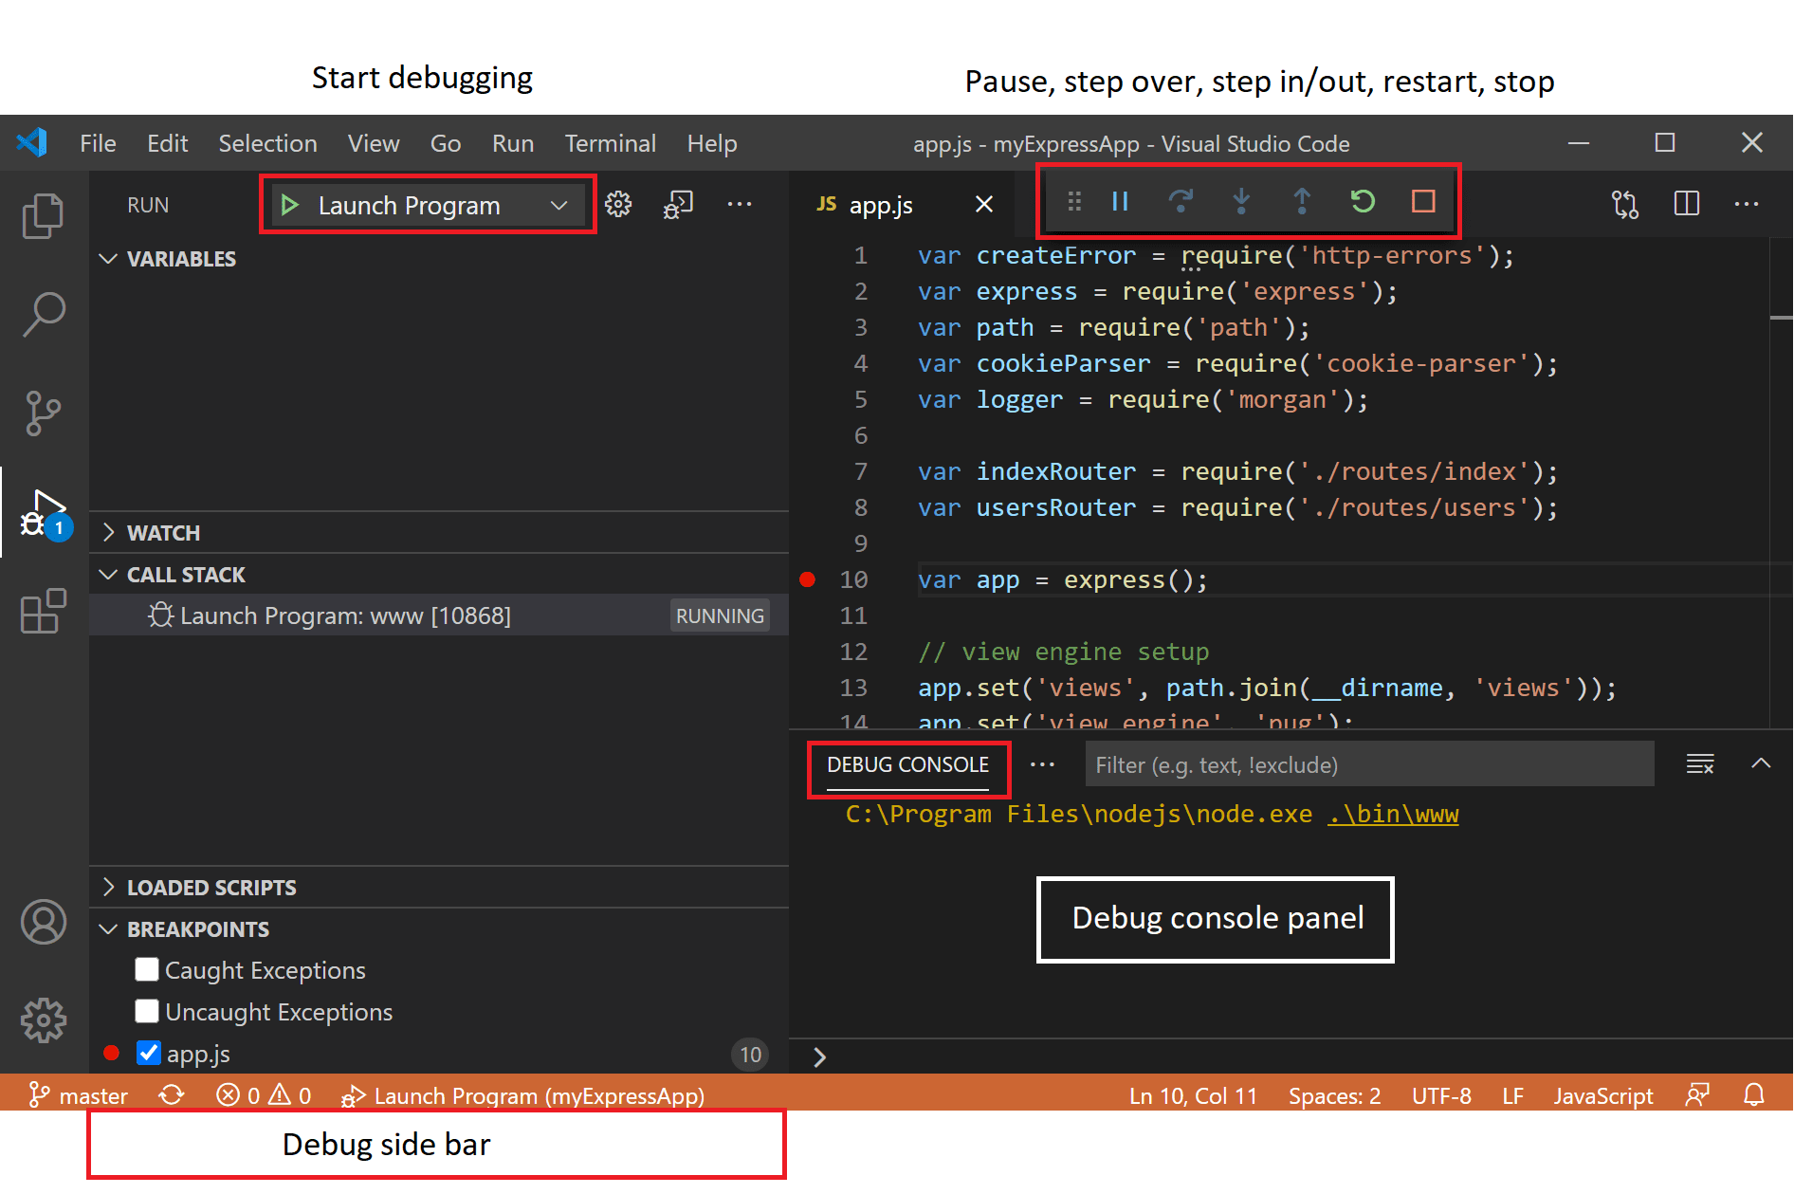

### Using Source Control

**Integrating Git with VS Code**

1.Initialize Repository:

* Open the Source Control view by clicking the Source Control icon in the Activity Bar.
* Click "Initialize Repository".
* Watch a demo on YouTube: Link to Demo

2.Making Commits:

* Stage changes by clicking the + icon next to files.
* Enter a commit message and click the checkmark to commit.
* Watch a demo on YouTube: Link to Demo

3.Pushing to GitHub:

* Use the Command Palette (Ctrl+Shift+P) and type Push to push commits to the remote repository.

## References

Visual Studio Code Documentation, 2024. Settings Sync. Available at: https://code.visualstudio.com/docs/editor/settings-sync [Accessed 14 June 2024].

Visual Studio Code Documentation, 2024. Theme and Appearance. Available at: https://code.visualstudio.com/docs/getstarted/themes [Accessed 14 June 2024].

Visual Studio Code Marketplace, 2024. Extensions. Available at: https://marketplace.visualstudio.com [Accessed 14 June 2024].

Visual Studio Code Documentation, 2024. Editor Settings. Available at: https://code.visualstudio.com/docs/getstarted/settings [Accessed 14 June 2024].

Visual Studio Code Documentation, 2024. Activity Bar. Available at: https://code.visualstudio.com/docs/getstarted/userinterface#_activity-bar [Accessed 14 June 2024].

Visual Studio Code Documentation, 2024. Side Bar. Available at: https://code.visualstudio.com/docs/getstarted/userinterface#_side-bar [Accessed 14 June 2024].

Visual Studio Code Documentation, 2024. Editor Group. Available at: https://code.visualstudio.com/docs/getstarted/userinterface#_editor-group [Accessed 14 June 2024].

Visual Studio Code Documentation, 2024. Status Bar. Available at: https://code.visualstudio.com/docs/getstarted/userinterface#_status-bar [Accessed 14 June 2024].

Visual Studio Code Documentation, 2024. Initialize Repository. Available at: https://code.visualstudio.com/docs/editor/versioncontrol [Accessed 14 June 2024].

Visual Studio Code Documentation, 2024. Make Commits. Available at: https://code.visualstudio.com/docs/editor/versioncontrol [Accessed 14 June 2024].